CHAPTER 6: The mysterious universe
Worksheet 6.5

The big bang
Answers

Flow charting the big bang
- Complete the big bang flow chart by selecting the event from the list below that matches each
step in the sequence and rewriting it in the correct box. Enter a title for each box that summarises each event.
Correct order = E, C, I, D, F, J, G, A, H, B

Big bang events in random order:
A. Universe has cooled to 3000 °C; first atoms form.
B. Galaxies begin to form.
C. Time and space form; space expands rapidly.
D. Heavier matter forms — protons, neutrons.
E. Singularity exists — the big bang occurs.
F. Universe cools; reaches size of the solar system.
G. Atomic nuclei form.
H. First stars appear.
I. Light matter forms — electrons, positrons.
J. Universe has cooled to 10¹⁰ °C.
CHAPTER 6: The mysterious universe
Worksheet 6.5

Page 2

Evidence for the big bang
2. The following microwave map of the early universe (t = 380 000 years after big bang) was produced by a probe that orbited the Earth in 2001.
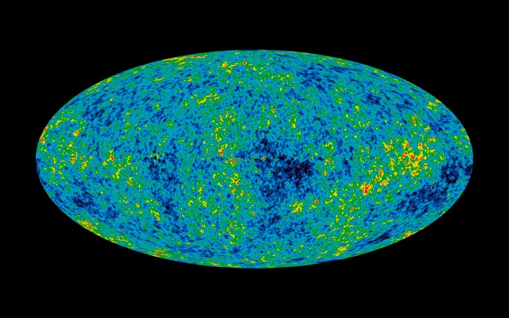
Photo: NASA
(a) The map shows that in the early universe matter was not uniformly distributed. Explain how this map supports the big bang theory.
The big bang theory states that the very early universe was very hot and that as it cooled matter particles started to form. As further cooling occurred, gravity caused the matter to condense and form lumps, eventually forming galaxies. The cosmic microwave background radiation map shows that the matter is not evenly spread, which is consistent with the expanding universe model.

(b) In 1948, Gamow and Alpher predicted that microwave radiation should now fill the universe. They proposed that this radiation was the cooled ‘afterglow’ of the big bang. When was this microwave radiation first detected?
1965

